71. Carrier Sense Multiple Access (CSMA) – a Random Access Protocol’s sub-protocol

Outcomes of the session are

* Understanding the Random Access Protocol’s types.
* Understanding the Carrier Sense Multiple Access Protocol.
* Types of CSMA.
* Behavior of 3 persistent methods.

Types of Random Access Protocol

1. ALOHA.
2. CSMA – Carrier sense multiple access.
3. CSMA/CD – Carrier sense multiple access with Collision detection.
4. CSMA/CA – Carrier sense multiple access with Collision Avoidance.

Carrier Sense Multiple Access Protocol-

* As the name suggests, the carrier sense multiple access checks the carrier and then processes to either continue the data transmission or discard, based on the status of the transmission medium availability.
* The status of transmission medium is either IDLE or BUSY.
* The CSMA method was developed to minimize the chance of collision and increase the performance.
* If the channel seems idle but another frame is traversing on the channel at a far distance towards another frame, the collision may happen.
* Principle of CSMA = “sense before transmit” or “listen before talk” in generalized manner.
* The chances of the frame collision still exists due to the propagation time.

The four types of CSMA are –

1-Persistent CSMA.

P-Persistent CSMA.

Non-Persistent CSMA.

O-Persistent CSMA.

1-Persistent CSMA –

* + Checks the channel if free or not and checks till the time the transmission medium becomes IDLE.
  + Since it returns value 1 during the checking, it is known as 1-Persistent CSMA.

Non-Persistent CSMA –

* + This type of CSMA does not check the channel continuously and is random in nature.
  + The previous transmission might be done, the channel might be free, but the station does not have a clue about it since its checking is random in nature.
  + If the channel is busy, this type of CSMA will not check continuously, rather wait for a random time.
  + It has less errors than 1-Persistent, but cause delays comparatively more.

P-Persistent CSMA –

* + It applies to Slotted Channels.
  + It does not sense free channel at a random time, it waits for the free slots in a sophisticated manner.
  + It waits for the full next interval and does not interfere till the next turn.
  + If the channel is idle, the data transmission takes place.
  + But if the channel is busy, it follows the following algorithm, Q = 1-p

Behavior of 3 different Persistent methods of CSMA -

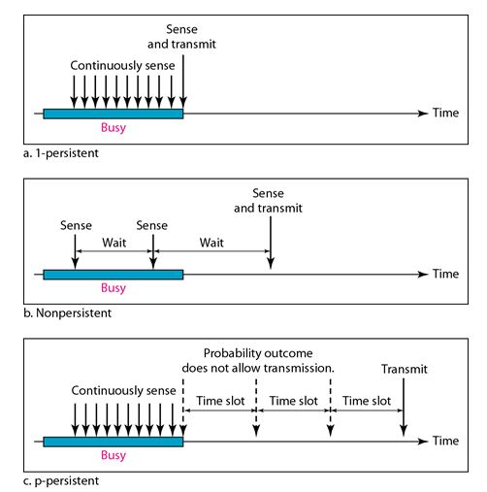

O-Persistent CSMA –

* + In the O-Persistent CSMA, the stations/nodes are ordered the sequence for data transmission by the supervisory nodes.
  + They are not random in nature.
  + This avoids collision or damaging of data.